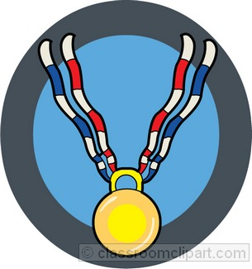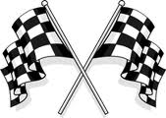

***On Your Mark, Get Set, Go!***

Pre-Reading is important because it serves as preparation before beginning a new book or text. With pre-reading strategies you are able to:

-Assess students’ background knowledge of the topic

-Provide students with necessary background knowledge for comprehension

-Clarify any misconceptions about the topic

-Introduce students to the type of text they will be reading

-Provide students with opportunities to collaborate and build on each other’s understanding through discussion

# **Importance of**

# **Pre-Reading Instruction**

<http://departments.weber.edu/teachall/reading/prereading.html>

<http://www.bankstreet.edu/literacyguide/pre.html>

<http://www.thinkport.org/technology/template.tp>

http://www.justreadnow.com/strategies/list.htm

[www.readwritethink.org](http://www.readwritethink.org)

**Visit our website for additional strategies and printable handouts at:** [**http://prereading.weebly.com**](http://prereading.weebly.com)

**Presented by: Amanda Linthicum and Danielle Lucas**

## **Helpful Websites**

***Literacy Strategies To Get Students Off on the Right Foot***

**Anticipation Guides-**

Anticipation Guides act as a pre-assessment and a post-assessment.  Students determine what their previous knowledge is about a topic, and then go back after reading and researching and compare what they have learned to what they thought before.  To extend this activity, have the students explain and justify their beliefs upon completing the reading/research.

**K.I.M. Vocabulary Strategy-**

This strategy allows the students to connect key words/phrases to information they learned about it, and encourages them to create a memory clue to help them remember the word.

**Semantic Mapping-**

This strategy connects key words of a reading selection to one another and group key words into categories.  This graphic organizer can also be a good tool for assisting collaboration between students as they discuss differing results.

**List, Group, Label-**

The List, Group, Label strategy offers a simple three-step process for students to organize a vocabulary list from a reading selection. This strategy stresses relationships between words and the critical thinking skills required to recognize these relationships.

**KWL-**

Having students document what they already know about a topic through the use of a KWL chart allows teachers to assess a student's previous knowledge. Students divide their paper into 3 columns. In the K column, they write what they already know about a topic.  In the W column, they write what they want to learn about the topic during your unit of study.  After the unit is complete, students can go into the third column and write what they have learned.

**PreP-**

The Pre-Reading Plan (PreP) helps students activate prior knowledge as a starting point for better reading comprehension. The PreP strategy guides students as they make associations between their prior knowledge and the central ideas in a reading selection.  Students are then able to reflect on these associations, comparing how the new information reinforces, extends, or challenges prior knowledge.

[Example of PreP](http://www.indiana.edu/~l517/PreP.htm)

# Pre-Reading Strategies for the Classroom

